EL SEWEDY UNIVERSITY OF TECHNOLOGY
Faculty of Engineering Technology

STUDENT PROJECT PROPOSAL
Academic Year 2025 / 2026

1. Project Information
Project Title | Intelligent Defect Detection in Modern Manufacturing — HAWK Factory
Program / Department | Computer Science & Network / Cyber Security · Faculty of Engineering Technology
Date of Submission | 2025 / 2026

Team Members
# | Full Name | ID | Specialization | Role on Team
1 | Marwa Mohamed | 240102975 | Computer Science | Team Leader
2 | Norhan Rafik | 240102862 | Computer Science | Team Member
3 | Doha Ramy | 240102408 | Computer Science | Team Member
4 | Alaa Adel | 230105740 | Computer Science | Team Member
5 | Mahmoud Kamal | 230105825 | Network & Cyber Security | Team Member
6 | Mohamed Abdelrazek | 240102743 | Network & Cyber Security | Team Member
7 | Noor Hany Ragb | 240101062 | Network & Cyber Security | Team Member

Supervisor
Name | Dr. Sahar Kamal
Email | sahar.kamal@sut.edu.eg
Department | Faculty of Engineering Technology

Industry Partner / Stakeholder (if any)
Organization
Contact Person
Nature of Collaboration

2. Project Overview
Abstract / Summary
HAWK Factory is an AI-powered visual-inspection platform that brings automated quality control to modern production lines. A custom YOLOv8 detector, HAWK-YOLO, watches each unit on a moving inspection station, decides in real time whether it is good or defective, and — when a defect is present — localises exactly where it is. Every verdict is logged to a database and shown on a bilingual (Arabic / English) dashboard, while a small servo automatically sweeps defective parts off the line. Trained on the project’s own product imagery together with public industrial defect datasets, the model reaches a mean average precision (mAP@50) of 98.9% at about 35 ms per image. The whole inspection station is built from inexpensive, off-the-shelf parts, so the same capability that normally carries a four- or five-figure industrial price tag can be reproduced in a small workshop — making reliable, real-time defect detection affordable for manufacturers of every size.

Keywords: Defect Detection · Deep Learning · YOLOv8 · Computer Vision · Industry 4.0 · Quality Inspection

3. Problem Statement, Market Need & Industry Relevance
3.1 Problem Definition
Modern manufacturing lines produce thousands of units per hour, and every one must meet the same quality standard. Today that check is still largely manual or rule-based: human inspectors tire and judge inconsistently, while classical rule-based vision is highly sensitive to lighting and surface variation and fails silently on any defect it was not explicitly tuned for. The result is that defective units slip through undetected. There is a clear gap for an inspection method that is automated, consistent, fast enough for the line, and able not just to flag a defect but to point to exactly where it is.

3.2 Industrial or Societal Relevance
Quality directly affects competitiveness across Egypt’s and the world’s manufacturing, automotive, electronics and pharmaceutical sectors. Undetected defects translate into scrap, rework, recalls and lost customer trust. The cost is concrete: in the project’s own analysis, a line producing 1,000 units a day with a 5% defect rate and a $2.50 cost per defective unit would save an estimated $1,250 per day simply by catching defects automatically. As Industry 4.0 raises both throughput and precision expectations, reliable automated inspection becomes a condition of survival rather than a luxury.

3.3 Market Need / Value Proposition
The direct users are quality-control teams and production engineers in automotive, electronics, pharmaceutical and precision-manufacturing plants. Because the inspection station is assembled from commodity components for roughly 55–75 US dollars in total, the solution also reaches a market that industrial vision systems normally exclude — small factories and workshops that cannot justify a four- or five-figure smart-camera installation. The value proposition is simple: industrial-grade, real-time defect detection at a fraction of the usual cost.

4. Objectives & Success Criteria

# | Objective | Success Criterion (measurable)
1 | Develop a deep-learning model that detects and localises surface defects on production units. | HAWK-YOLO reaches mAP@50 ≥ 0.98 (achieved 0.989) with precision ≥ 0.98 (achieved 0.985).
2 | Run inspection in real time on a live camera feed. | Per-image inference ≤ ~40 ms (achieved ~35 ms per image).
3 | Automatically reject defective units on a physical inspection station. | A defective unit is swept off the disc within ~0.1 s of being detected.
4 | Provide an operator-facing platform around the model. | Bilingual (EN/AR) dashboard with multi-camera, multi-tenant device stats and a REST API.
5 | Keep the inspection station low-cost and reproducible. | Complete station built from off-the-shelf parts for a total BOM of ≈ 55–75 USD.

5. Innovation & Expected Impact
5.1 What Makes This Project Innovative
Most academic defect-detection work stops at a notebook that classifies an image; most industrial systems that go further are proprietary and expensive. HAWK Factory’s contribution is to cross that gap end-to-end: a custom-trained YOLOv8 detector that both classifies and localises the defect, wrapped in a deployable, multi-camera, multi-tenant platform that is wired to a real physical reject mechanism — and built entirely from commodity hardware, so the whole capability is reproducible in a small workshop for the cost of dinner for two.

5.2 Expected Impact
☑ | Cost saving / efficiency improvement
☐ | Energy or environmental sustainability
☑ | Industry collaboration / industrial scale-up potential
☐ | Community benefit / social impact
☑ | Educational or research contribution
☐ | Other (specify below)

By catching defects automatically and in real time, the system reduces scrap, rework and recalls — the project’s own example scenario estimates savings of about $1,250 per day for a single line — while remaining cheap enough to deploy widely.

6. Methodology & Technical Approach
6.1 Approach Overview
The approach moves from data to a deployed, working station in five stages. (1) Data collection: surface-defect imagery is gathered from four public industrial datasets — MVTec AD, NEU Surface Defect, DAGM 2007 and KolektorSDD — together with the team’s own product images. (2) Preprocessing: images are resized, normalised and augmented, and transfer learning is used to start from strong pretrained weights. (3) Modelling: a custom YOLOv8 detector (HAWK-YOLO) is trained for 150 epochs to both classify each unit and draw a bounding box around any defect; it is benchmarked against CNN, MobileNet and EfficientNet-B0 baselines. (4) Platform: the trained model is served through a Flask REST API behind a bilingual dashboard, with results stored in a SQLite database and combined across cameras using a configurable decision-fusion rule (ANY / ALL / MAJORITY). (5) Physical integration: an overhead camera images each unit on a rotating-disc station, and an Arduino-driven servo sweeps defective units off the line within about a tenth of a second.

6.2 Tools, Hardware & Software
Hardware platforms | Arduino Uno R3 · USB webcam (1080p, e.g. Logitech C270) · MG996R servo motor · IR obstacle sensor (TCRT5000 / FC-51) · LED ring light · rotating-disc turntable · MDF chassis
Software & languages | Python · PyTorch / Ultralytics YOLOv8 · OpenCV · Flask (REST API) · SQLite · HTML / JS dashboard (Chart.js)
Datasets / standards | MVTec AD · NEU Surface Defect · DAGM 2007 · KolektorSDD · in-house product imagery
Methods / algorithms | Custom YOLOv8 object detection (HAWK-YOLO) · transfer learning · data augmentation · decision fusion (ANY / ALL / MAJORITY)

6.3 Block Diagram / Process Flow
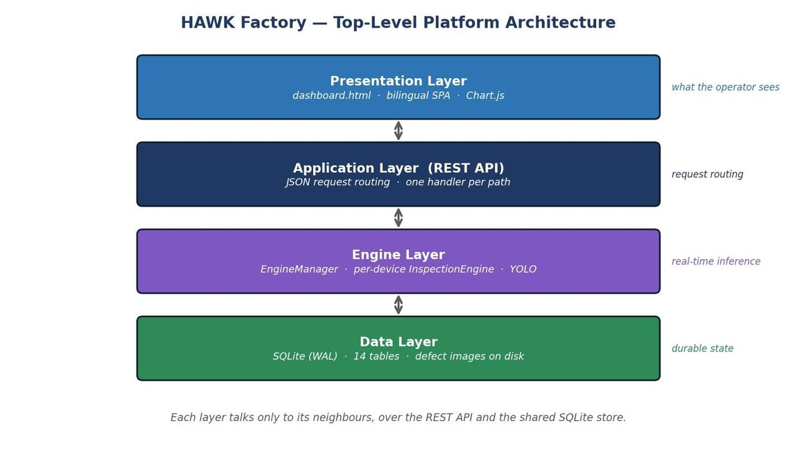

7. Project Deliverables
 | Deliverable | Description
☑ | Working prototype / hardware system | Physical rotating-disc inspection station with camera, Arduino and servo reject.
☑ | Software / source code | HAWK Factory platform — YOLO inference engine, Flask REST API, bilingual dashboard and SQLite database.
☑ | Technical report & documentation | Full graduation book documenting the design, methodology, training and results.
☑ | Final presentation | Project defense presentation.
☐ | Demonstration video
☑ | Dataset / analysis output | In-house labelled defect imagery plus the model’s training and evaluation results.
☐ | Other (specify)

8. Timeline & Milestones
Phase / Milestone | Start Date | End Date | Deliverable | Responsible Member
Literature Review & Requirements |  |  | Requirements & dataset survey
Design & Methodology |  |  | System design & model plan
Prototype Development |  |  | HAWK-YOLO model + platform + station
Testing & Validation |  |  | Benchmark results (98.9% mAP@50)
Final Report & Defense |  |  | Graduation book & final presentation

9. Resources & Estimated Budget
9.1 Required Resources
A workstation / GPU for training the YOLOv8 model; basic electronics-lab access and a USB webcam; a laser-cutting service for the MDF chassis panels; and the public datasets (MVTec AD, NEU, DAGM 2007, KolektorSDD).

9.2 Estimated Budget (Bill of Materials)
Item / Component | Quantity | Unit Cost (EGP) | Total (EGP)
USB webcam 1080p (Logitech C270 or compatible) | 1 | 900 | 900
LED ring light / strip | 1 | 350 | 350
Arduino Uno R3 (+ USB A–B cable) | 1 | 650 | 650
IR obstacle sensor (TCRT5000 / FC-51) | 1 | 100 | 100
Servo motor (MG996R, metal-gear) | 1 | 500 | 500
Rotating-disc turntable, MDF chassis & wiring | 1 | 2,500 | 2,500
TOTAL ESTIMATED BUDGET |  |  | 5,000 EGP

Funding Source (if any):

10. Risk Assessment & Safety Considerations
# | Risk | Likelihood | Impact | Mitigation
1 | Lighting / surface variation degrading detection | Medium | High | Controlled LED ring lighting plus data augmentation; model trained on varied imagery.
2 | Limited or imbalanced defect samples | Medium | Medium | Use of public datasets (MVTec, NEU, DAGM, KolektorSDD) with augmentation and transfer learning.
3 | False accept / false reject on the line | Low | High | High precision (0.985) and decision fusion (ANY / ALL / MAJORITY) across cameras.
4 | Servo / hardware reliability | Low | Medium | Simple Arduino-driven servo; reproducible off-the-shelf build verified by a second team.
5 | Real-time latency on modest hardware | Low | Medium | Lightweight YOLOv8 (~35 ms / image); MobileNet and EfficientNet baselines evaluated.

Safety Precautions
Standard electronics-lab safety: correct low-voltage power isolation for the Arduino and servo, careful handling of the rotating disc and moving servo arm, and tidy, secured wiring. No hazardous chemicals or high voltages are involved.

11. References

Your References:
- [1] P. Bergmann, M. Fauser, D. Sattlegger, and C. Steger, “MVTec AD — A Comprehensive Real-World Dataset for Unsupervised Anomaly Detection,” in Proc. IEEE/CVF CVPR, 2019, pp. 9592–9600.
- [2] G. Jocher et al., “YOLOv8 by Ultralytics,” Software Release, Ultralytics, 2023. [Online]. Available: https://github.com/ultralytics/ultralytics
- [3] J. Redmon, S. Divvala, R. Girshick, and A. Farhadi, “You Only Look Once: Unified, Real-Time Object Detection,” in Proc. IEEE CVPR, 2016, pp. 779–788.
- [4] M. Tan and Q. V. Le, “EfficientNet: Rethinking Model Scaling for Convolutional Neural Networks,” in Proc. ICML, 2019.
- [5] D. Tabernik, S. Šela, J. Skvarč, and D. Skočaj, “Segmentation-Based Deep-Learning Approach for Surface-Defect Detection,” J. Intelligent Manufacturing, vol. 31, no. 3, pp. 759–776, 2020.

12. Supervisor Background, Related Projects & Expertise
12.1 Brief Background & Expertise

12.2 Related Projects Previously Supervised
- ……………………………………………………………………………………………………………………………………………………
- ……………………………………………………………………………………………………………………………………………………
- ……………………………………………………………………………………………………………………………………………………

Approval & Signatures
Role | Name | Signature & Date
Supervisor | Dr. Sahar Kamal

